Rocky Grove Avenue Presbyterian Church

321 Rocky Grove Avenue

Franklin, PA 16323

**MC900116408[1]**

**SONSHINE NEWSLETTER**

**March 2022**

A Publication of Rocky Grove Avenue Presbyterian Church

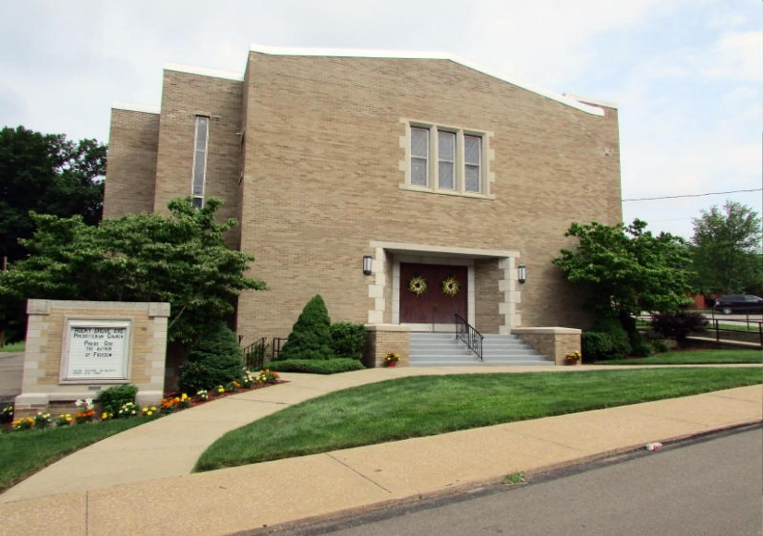

***“Sharing, Preparing and Caring in Jesus’ Name”***

**Rocky Grove Avenue Presbyterian Church**

321 Rocky Grove Avenue, Franklin, PA 16323

Church Phone: 814-432-4162

Website: www.rockygrovepres.org

Email Address: rgapc@verizon.net

**Worship – 9:00 a.m.**

***Church Staff***

Rev. Rachel J. Johns, Pastor

Rhonda Rust, Secretary

Mike Burkhardt, Organist

Janet Bish, Assistant Organist

Scott Donaldson, Custodian

***Church Office Hours***

*Tuesday, Wednesday & Thursday: 8:30 a.m. to 1:00 p.m.*



If you would like to provide flowers for Sunday morning worship, please contact the church office (814-432-4162). You will want to advise as to whether you will order your own flowers, how you want it listed in the bulletin and if you will be removing them after the service.

**~~~~~~~~~~~~~~~~~~~~~~~~~~~~~~~~~~~~~~~~~~~**



***MARCH Birthdays***

4 Aaron Wetjen (16) 27 Eleanore Moffitt

6 Kevin Songer 30 John Dumbleton

10 Rodney Zeller

**~~~~~~~~~~~~~~~~~~~~~~~~~~~~~~~~~~~~~~~~~~~**

**

**Servants for MARCH**

**Recorders:** Lois Pierce & Joyce Wetjen

**Worship Leaders:** 6 Rhonda Rust

13 Pastor Rachel Johns

20 Lois Pierce

27 Rhonda Rust

**~~~~~~~~~~~~~~~~~~~~~~~~~~~~~~~~~~~~~~~~~~~**

**Lake Erie Presbytery Prayer List for month of March**

**Week of March 6th**

*Rev. Dr. Lawson Dzanko,* Clerk of the General Assembly,

Evangeline Presbyterian Church, Ghana

*Rt. Rev. Lt. Col. Bliss Divine Agbeko,*

Moderator of the General Assembly,

Evangelical Presbyterian Church, Ghana

**Week of March 13th**

Woodcock Gravel Run Presbyterian Church

*Rose Hilliard,* Commissioned Pastors

*Rev. Barry Cressman* (Honorably Retired)

*Rev. Jim Haas* (Honorably Retired)

**Week of March 20th**

Waterford Presbyterian Church

*Rev. Robin Sharp,* Pastor

*Rev. Sheldon Logan* (Honorably Retired)

*Rev. Chuck Cammarata* (Honorably Retired)

**Week of March 27th**

Tionesta Presbyterian Church

*Roger Snyder, Kevin Vinson,* Commissioned Pastor

*Rev. Samuel Mabugh* (ELCA)

*Rev. Anita Bernhardt*

Presbytery of Lake Erie General Presbyter

**~~~~~~~~~~~~~~~~~~~~~~~~~~~~~~~~~~~~~~~~~~~**

**Answers to St. Patrick’s Day Crossword Puzzle**

Across: 4) Dublin 5) Jig 7) Pinch 9) Seventeenth 11) Shamrock

12) Green 13) Irish

Down: 1) March 2) Luck 3) Blarney 6) Ireland 7) Potato

8) Leprechaun 10) Clover

**MISSIONS CORNER:**

A total of $160.00 and five (5) jars of peanut butter was collected on Sunday, February 13th, for Souper Bowl of Caring; the proceeds were sent to Community Services of Venango County to help fund the Rocky Grove Food Pantry.



**~~~~~~~~~~~~~~~~~~~~~~~~~~~~~~~~~~~~~~~~~~~**

Lent begins March 2nd with Ash Wednesday. **One Great Hour of Sharing** offering will again be collected during Lent this year. Your

contributions will help with disaster assistance, alleviating hunger as well as helping people learn how to help themselves towards a better life. Envelopes for donations will be in the pews and also in the April newsletter. Donations to OGHS offering will be accepted through Easter – April 17, 2022.

**~~~~~~~~~~~~~~~~~~~~~~~~~~~~~~~~~~~~~~~~~~~~**



***SPRING AHEAD!***

**Don’t forget to change your clocks upon retiring Saturday evening, March 12th, so as to be on time for church Sunday morning, March 13th!!!!!**

**~~~~~~~~~~~~~~~~~~~~~~~~~~~~~~~~~~~~~~~~~~~~~~~**



|  |
| --- |
| **MARCH 2022** |

|  |  |  |  |  |  |  |
| --- | --- | --- | --- | --- | --- | --- |
| SUNDAY | MONDAY | TUESDAY | WEDNESDAY | THURSDAY | FRIDAY | SATURDAY |
|  |  | **1**  **6:30 Sweet Adelines** | **2**  **Ash Wednesday** | **3** | **4**  ***World Day of Prayer*** | **5**  **9:30** Overeaters  Anonymous |
| **6**  **9:00 Worship** *~*  *1st Sunday in Lent* | **7**  **6:00 Trustees** | **8**  **6:30 Sweet Adelines**  ***International Women’s Day*** | **9** | **10** | **11** | **12**  **9:30** Overeaters  Anonymous |
| **13**  **9:00 Worship** *~*  *2nd Sunday in Lent*  ***Daylight Savings Time begins*** | **14** | **15**  **1:15 Session**  **6:30 Sweet Adelines** | **16** | **17**  **Saint**  **Patrick’s**  **Day** | **18** | **19**  **9:30** Overeaters  Anonymous |
| **20**  **9:00 Worship** ~  *3rd Sunday in Lent*    ***First Day of Spring!!*** | **21** | **22**  **NEWSLETTER**  **DEADLINE**  **6:30 Sweet Adelines** | **23** | **24** | **25** | **26**  **9:30** Overeaters  Anonymous |
| **27**  **9:00 Worship**  ~  *4th Sunday in Lent* | **28** | **29**  **6:30 Sweet Adelines** | **30** | **31** | ***April***  ***Sonshine Newsletter***  **available:** [www.rockygrovepres.org](http://www.rockygrovepres.org) |  |

***Newsletter articles are due in the church office by the 20th of each month or risk being omitted from next month’s issue.***